Lesson 03 Demo 08

Creating File Share Snapshot

Objective: To create a file share snapshot for accessing the deleted files
Tools Required: None

Prerequisites: Existing file share

Steps to be followed:
- Create a file share snapshot

Step 1: Create a file share snapshot

- Go to the Azure portal and navigate to the file share that was already created

- Select Snapshots from the left menu under Operations

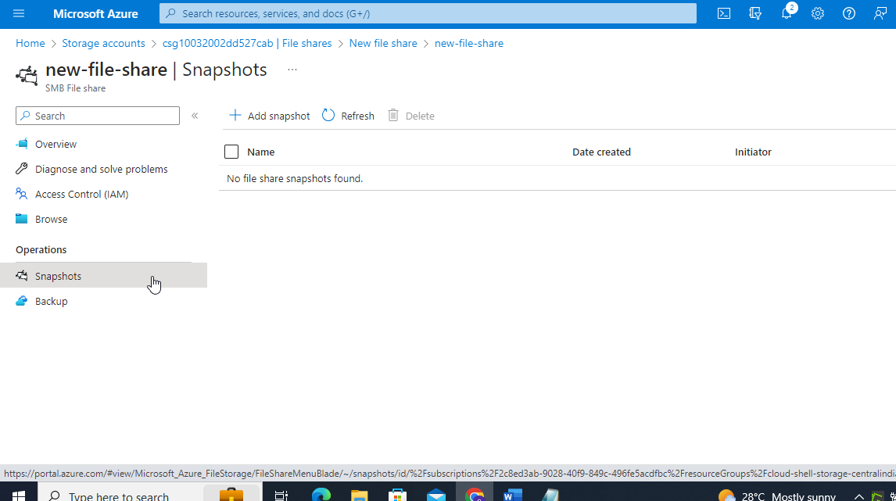

- Click on Add snapshot and then select OK when prompted

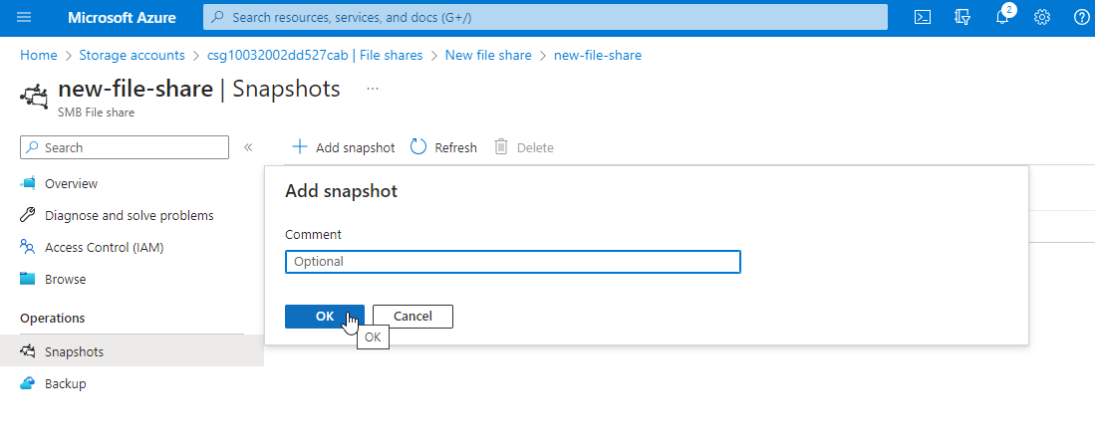

- Verify that the snapshot is created

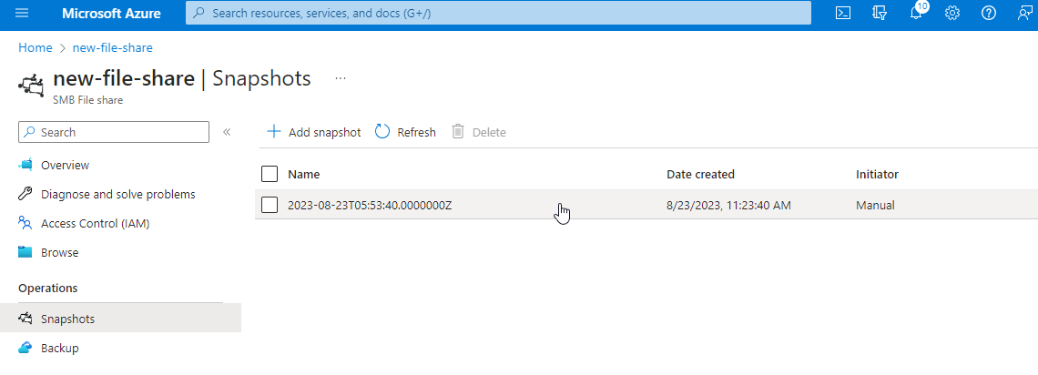

- Click on the Snapshot and verify if it contains the uploaded file (Refer to demo 7: Manage or Mount File Share)

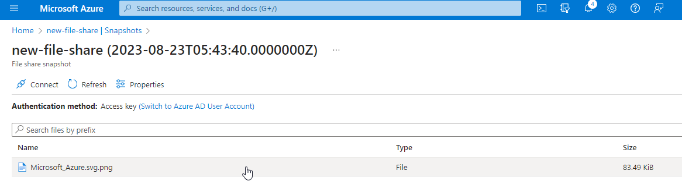

- Click on the file that is a part of the Snapshot and review the File properties

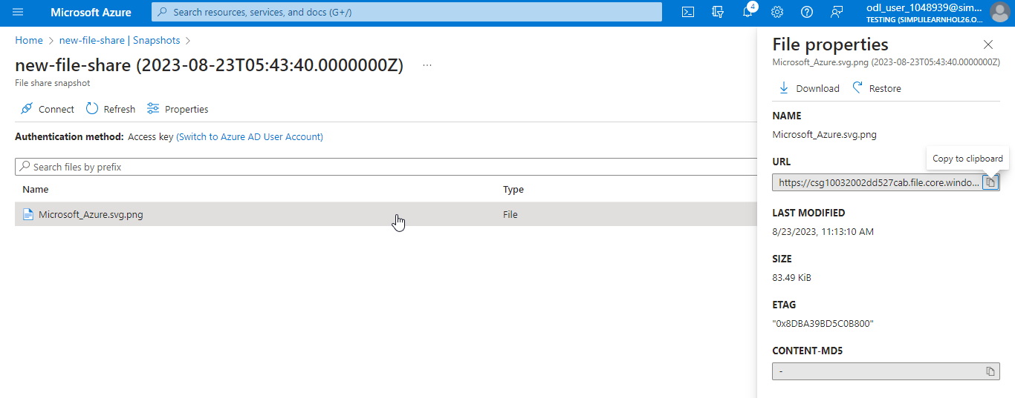

- Observe the choices to Download and Restore the snapshot file

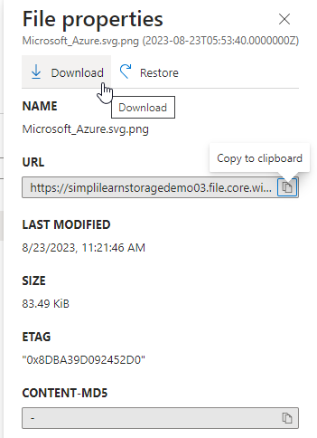

- Access the file share and Delete the file that was previously uploaded

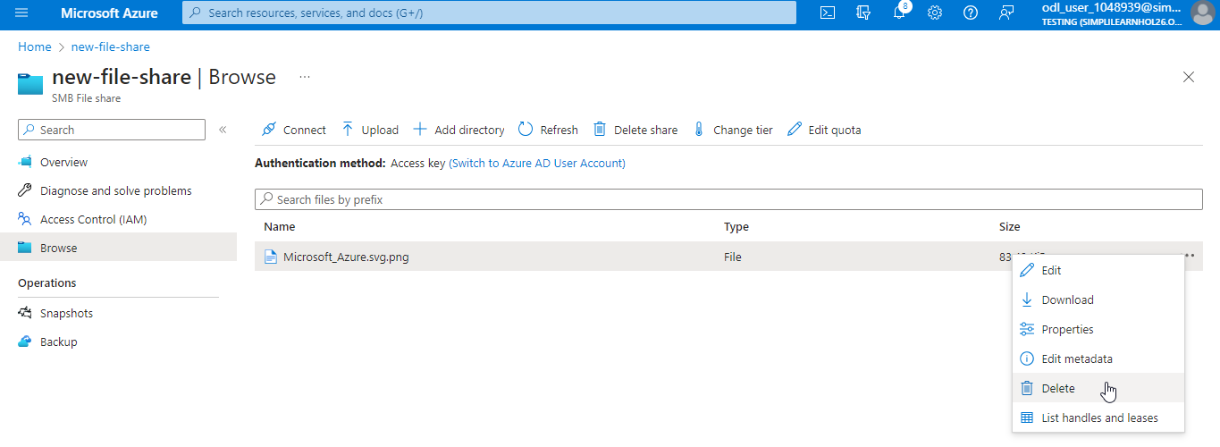

- Navigate to the file properties within the Snapshot and Restore the previously deleted file

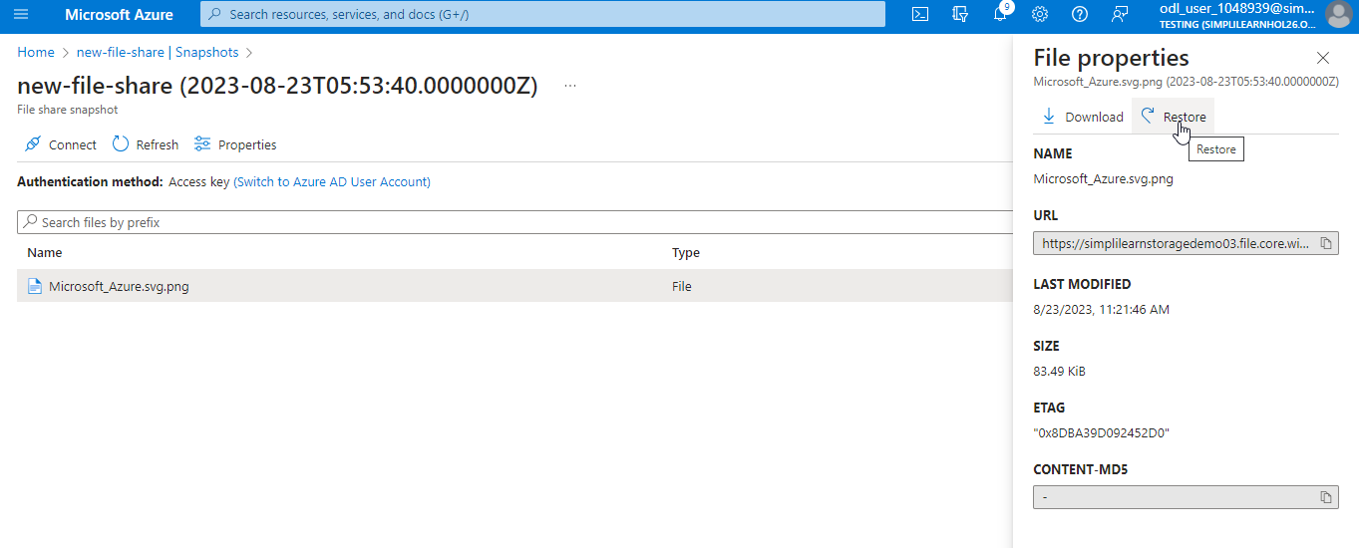

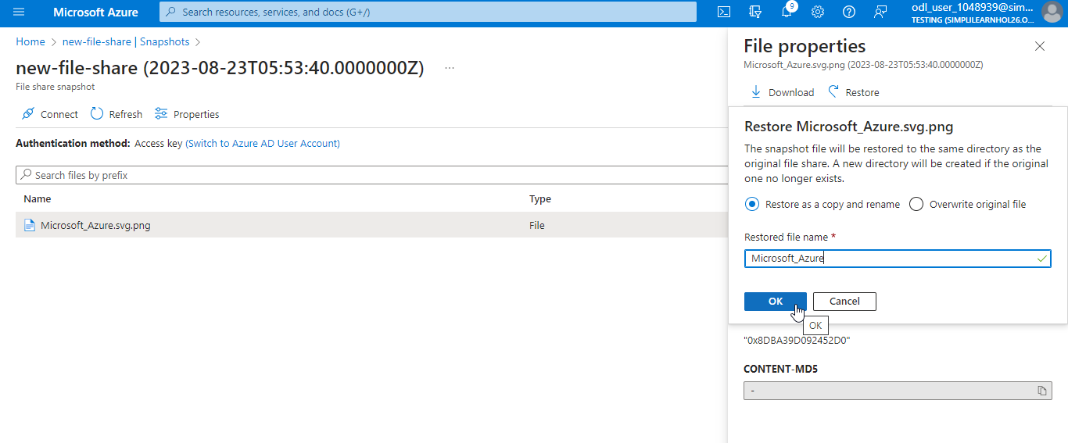

You have now comprehended that a deleted file from the file share remains accessible in the snapshot and can be restored.

